**Lab 4 : Threads**

**1. Creating new thread using pthread_create() function and executing a user-defined**

**function show().**

ls

mkdir threads

cd threads

nano thread.c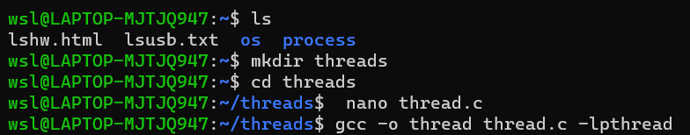

Program:

#include<stdio.h>

#include<pthread.h>

#include<time.h>

void * show(void * u){

printf("New thread\n");

}

int main(){

pthread_t tid;

time_t t;

time(&t);

printf("\nThis program has been writeen at (date and time): %s", ctime(&t));

pthread_create(&tid,NULL,&show,NULL);

printf("Main thread\n");

pthread_join(tid,NULL);

return 0;

}

Output:

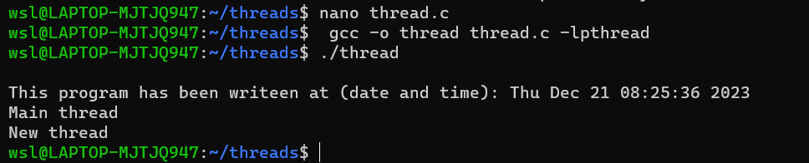

**2. The pthread_join() function waits for the thread specified by thread to terminate.**

**If that thread has already terminated, then pthread_join() returns immediately.**

nano thread_two.c

Program:

#include<stdio.h>

#include<pthread.h>

#include<stdlib.h>

#include <unistd.h>

#include<time.h>

int value=1;

void * sleep_a(void * u){

printf("New boy\n");

value=value+5;

printf("\nI am going to sleep for %d seconds: ",value);

sleep(value);

printf("\nI slept for %d seconds: \n",value);

}

void * sleep_b(void *u){

printf("old boy\n");

value=value+2;

printf("\nI am going to sleep for %d seconds: ",value);

sleep(value);

printf("\nI slept for %d seconds: \n",value);

}

int main(){

pthread_t tid,tid2;

time_t t;

time(&t);

printf("\nThis program has been writeen at (date and time): %s", ctime(&t));

pthread_create(&tid,NULL,&sleep_a,NULL);

pthread_create(&tid2,NULL,&sleep_b,NULL);

printf("Main thread\n");

pthread_join(tid,NULL);

pthread_join(tid2,NULL);

return 0;

}

Output:

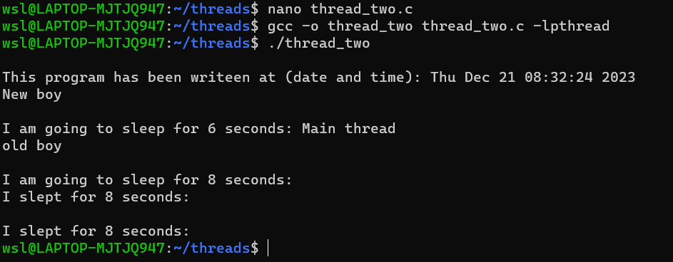

**3. Creating thread and creating its child process**

nano thread_process.c

Program:

#include<stdio.h>

#include<pthread.h>

#include<unistd.h>

#include<stdlib.h>

#include<time.h>

void * show(void * u){

int pid;

printf("OLD BOY\n");

printf("\nThis is thread its pid is no. %d\n",getpid());

}

int main(){

int pid;

pthread_t tid;

pthread_t tid_child;

time_t t;

time(&t);

printf("\nThis program has been writeen at (date and time): %s", ctime(&t));

pthread_create(&tid,NULL,&show,NULL);

printf("Main thread\n");

printf("\nThe pid of main thread is %d: \n",getpid());

printf("\nThe ppid of main thread is %d: \n",getppid());

pid=fork();

if(pid==0){

printf("\nThis is child\n");

printf("\n The id of child is %d\n",getpid());

printf("\n My parent is %d: ",getppid());

exit(0);

}

pthread_join(tid,NULL);

return 0;

}

Output:

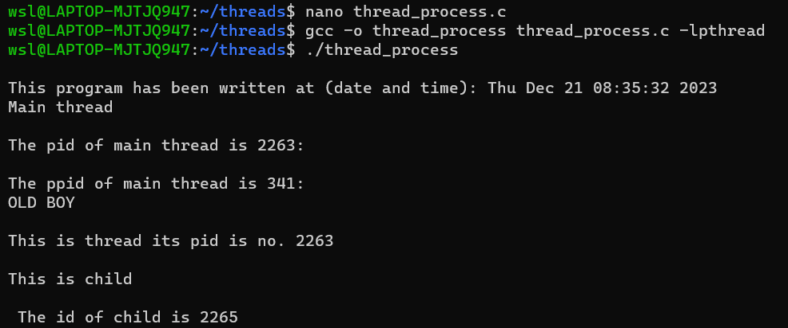

**4. Demonstration of creating thread by passing function and its argument as parameter to the pthread_create() function.**

nano thread_argument.c

Program:

#include <pthread.h>

#include <stdio.h>

#include<stdlib.h>

#include<unistd.h>

#include<time.h>

#include<stdlib.h>

int global;

void square(){

global = global*global;

}

void cube(){

global = global*global*global;

}

void *PrintHello(void *choice) {

int *id_ptr, taskid;

sleep(1);

id_ptr = (int *) choice;

taskid = *id_ptr;

printf("\nEnter a number: ");

scanf("%d",&global);

if(taskid==0){

square();

printf("\nthe square is %d: \n",global);

}

else if(taskid==1){

cube();

printf("\nthe cube is %d: \n",global);

}

pthread_exit(NULL);

}

int main( ) {

pthread_t threads;

int *choice=malloc(sizeof(int*));

int rc;

time_t t;

time(&t);

printf("\nThis program has been writeen at (date and time): %s", ctime(&t));

printf("\n Enter a choice: 0 for square and 1 for cube number: ");

scanf("%d",choice);

printf("Creating thread \n");

rc = pthread_create(&threads, NULL, PrintHello, (void *)choice);

if (rc) {

printf("ERROR; return code from pthread_create() is %d\n", rc);

exit(-1);

}

pthread_exit(NULL);

}

Output:

